25.Write a Python program to plot two or more lines with legends, different widths and
colors.
Aim:
To write a Python program using Matplotlib to plot two or more lines with different colors, line widths, and legends.
Code:
import matplotlib.pyplot as plt
x = [1,2,3,4,5]
y1 = [2,4,6,8,10]
y2 = [1,3,5,7,9]
plt.plot(x, y1, label="Line 1", linewidth=3, color="blue")
plt.plot(x, y2, label="Line 2", linewidth=2, color="red")
plt.xlabel("X")
plt.ylabel("Y")
plt.title("Multiple Lines")
plt.legend()
plt.show()
Output:
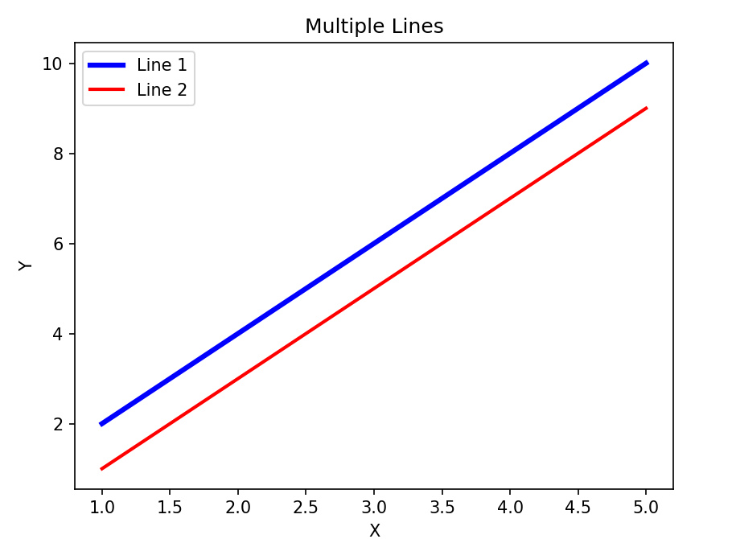

Result:
The program was executed successfully, and two lines were plotted with different colors and widths. A legend, X-axis label, Y-axis label, and title were also displayed.

26.Write a Python program to create multiple plots.
Aim
To write a Python program using Matplotlib to create and display multiple plots in a single figure.
Code:
import matplotlib.pyplot as plt
plt.subplot(2,1,1)
plt.plot([1,2,3],[2,4,6])
plt.title("First Plot")
plt.subplot(2,1,2)
plt.plot([1,2,3],[6,4,2])
plt.title("Second Plot")
plt.tight_layout()
plt.show()
Output:
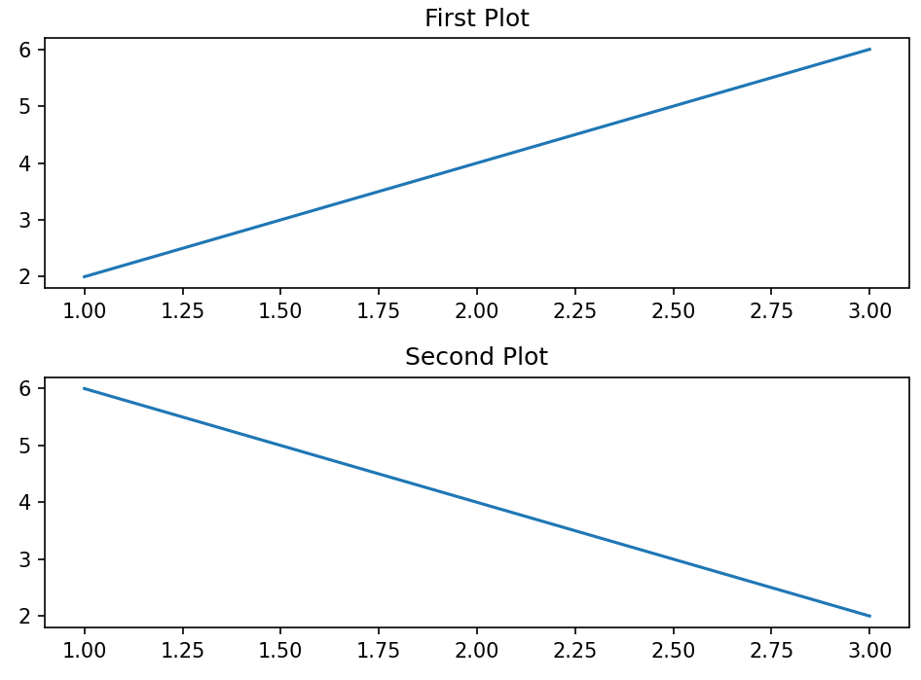

Result:
The program was executed successfully, and two plots were displayed in the same figure, one above the other.

